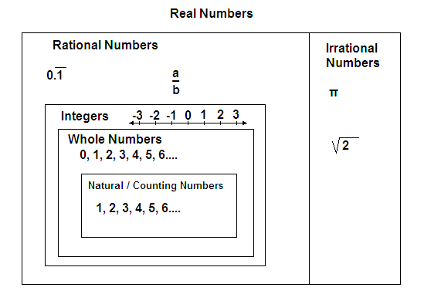

**Rational Numbers**

* decimals,
* percents,
* fractions
* Anu number that can be written as a fraction that repeats or terminates numbers

**Integers**

Positive and negative whole numbers

Whole numbers

* Begin with zero
* 0, 1, 2, 3, 4, …

Natural numbers

* aka_ Counting numbers
* Begin with 1
* 1, 2, 3, 4, 5, …